Chapter 3 Book Work
Logan Yeubanks
3.1:

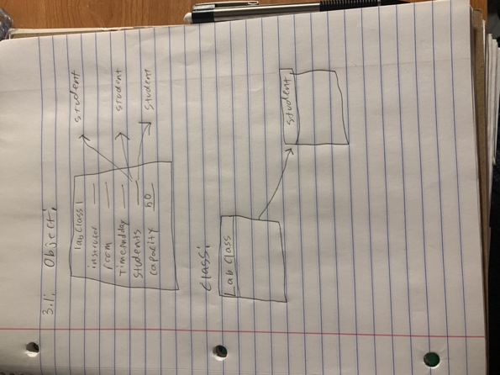

3.2: The class diagram would change when code changes within it.

3.4: private Instructor tutor;

3.5: hours.increment();

3.6: minutes.increment();
I would compare to see if increment leads to a rollover and then increase minutes by one of not. Otherwise, I would increment hours by one instead.

3.8: The error states that getValue cannot be referenced from a static context

3.9: A error indicating a .class is expected occurs.

3.10: Nothing happens. My solution would be to maybe print a error message indicating to only enter a valid value.

3.11: When the code is changed to that, 0 is no longer accepted.

3.12: The statement accepts if just one of the parameters is true.

3.13:

! (4 < 5) = false
! false = true
(2 > 2) || ((4 == 4) && (1 < 0) = false
(2 > 2) || (4 == 4) && (1 < 0) false
(34 != 33) && ! false = true

3.14: if (a && b || !a && !b)

3.15: if (a && !b) || !a && b)

3.16: if (a = b)

3.17: getDisplayValue does not appear to work with the value of 800.

3.18: No there is not a difference because both result in a string regardless of the order.

3.19: The first one printed out 12cat and the second printed out cat39

3.20: Modulo is done with the % sign and signifies division and returns the remainder of the division. A example would be 5%2 returning 1.
3.21: 2 is the result of 8 % 3 because it is the remainder of 8/3.

3.22: When negative numbers are used in both numbers or is the first number the answer comes out to be negative, but if the negative integer is second then the answer is positive. -5 % 2 = -1 and -5 % -2 = -1, but 5 % -2 = 1

3.23: The possible answers of n % 5 are 0, 1, 2, 3, 4.

3.24: The answer of n % m is all positive numbers within the bounds of a integer in Java.

3.25: Increment sets NumberDisplay to 0 if it has reached its limit by using the modulo operator.

3.26: public void newIncrement() {
value ++;
if ( value == limit){
value = 0;
}
}

3.27: I would think it starts at 0 because it has not incremented yet.

3.29: It would to be called 60 times or be set to 01:00 initially.

3.30: private Rectangle window
window = new Rectangle(1, 2);

3.31: The second constructor uses setTime to set the time to whatever parameters are passed into it. It then uses 24 and 60 as the rollover limit for when to call the increment method.

3.32: Both constructors set the rollover limits as hours = 24 and minutes = 60. However, the first constructor does not have parameters and uses updateDisplay instead of setTime. The second constructor uses setTime because there are parameters passed into it and with those parameters the setTime method sets the time to the integers indicated within them.

3.33:
1. p1.print(file_name, true);
p1.print(file_name, false);
2. p1.getStatus(1);
P1.getStatus(2);

3.34:
The objects created are the: wall, roof, sun, and window.

3.35:
roof.changeSize(60, 180);
roof.moveHorizontal(20);
roof.moveVertical(-60);
roof.makeVisible();

3.36: The picture class does not have an internal method call.

3.37:

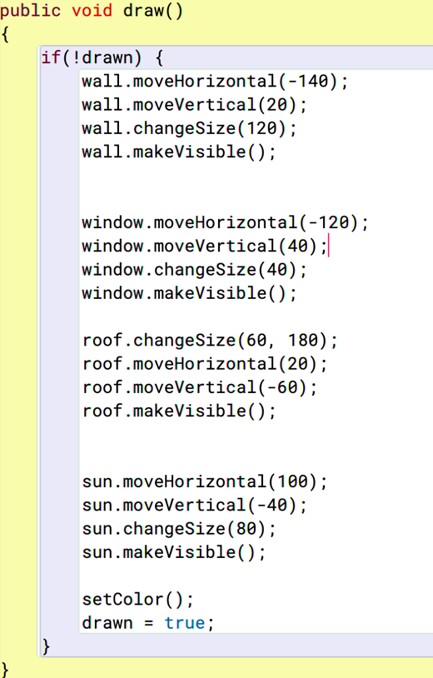

3.38:

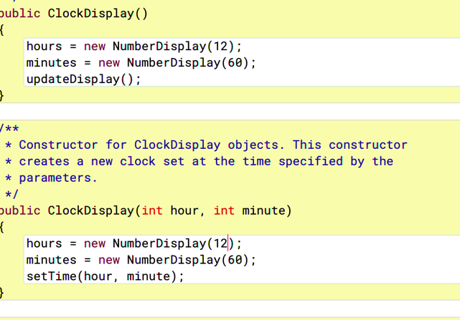

3.39:
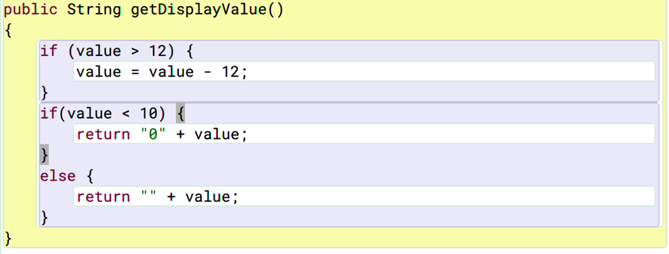

I preferred the first way that I did in 3.38 because it only required a single change to a few lines. Because of the simplicity I would also say it is better.

3.40:

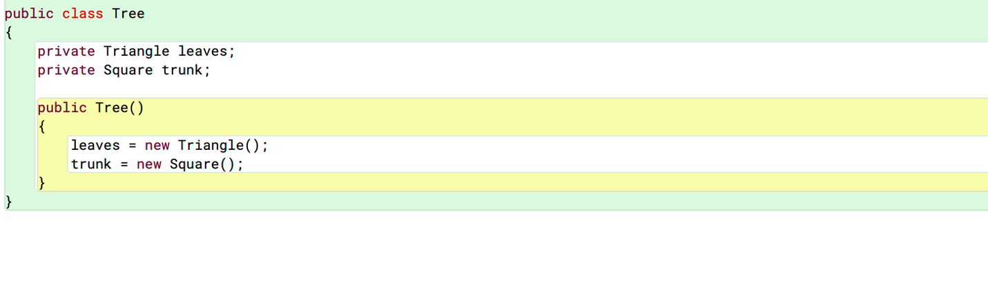

3.41:
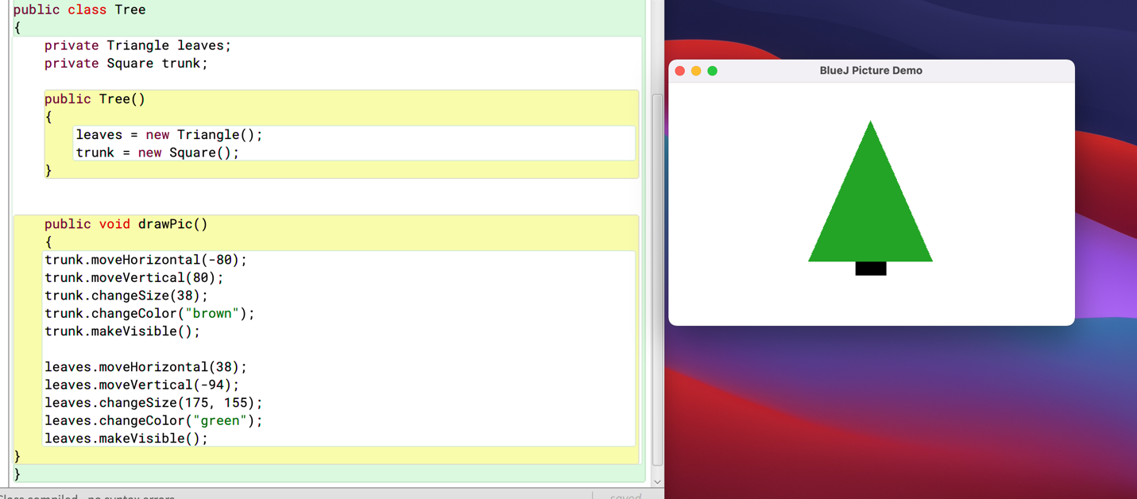

3.42:
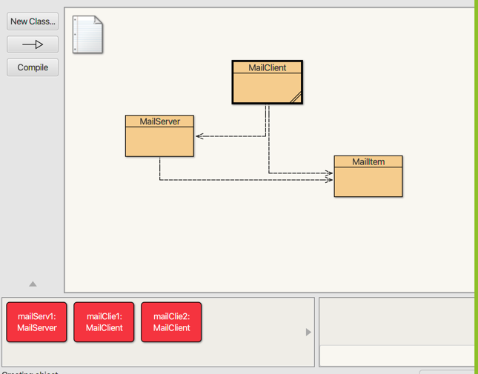

3.43:
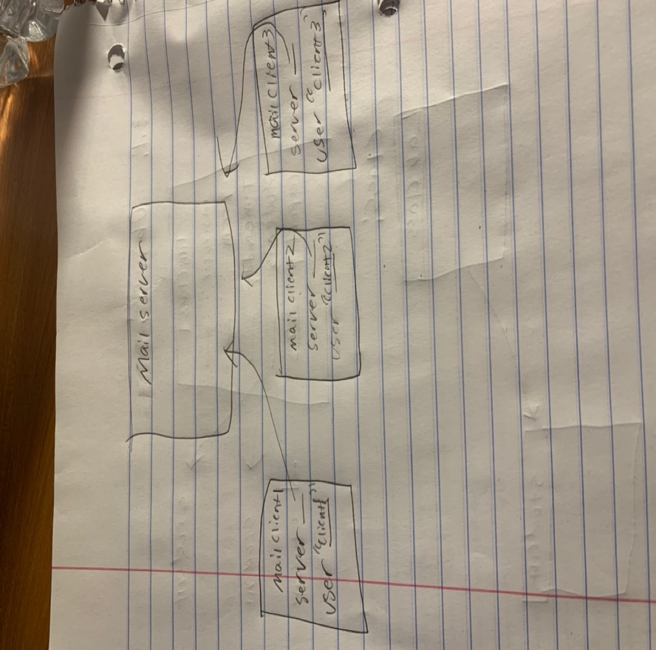

3.47: The debugger should step into the next line if(item == null) and nothing is going to happen because item = server.getMailItem instead of null.

3.48: The second time item now = null which then leads to “No new mail” being printed.

3.49: The contents of print showed and showed the predetermined strings such as From, and To.

3.51: New objects of MailItem are made when sendMailItem occurs and it comes from the server.
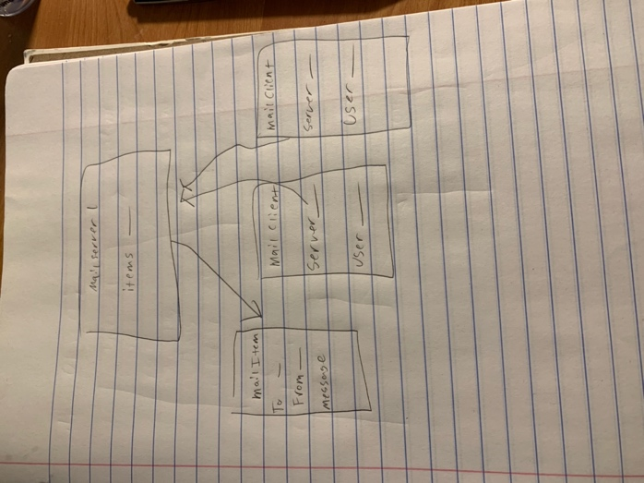

3.52: When I stepped throught the clockDisplay project it seemed as though everything was working as expected with if statements being skipped or stepped through if conditions were met.

3.54:
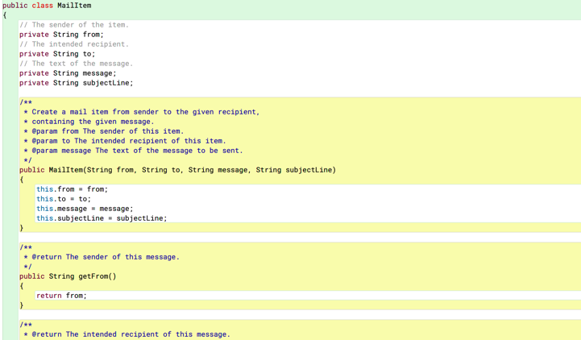

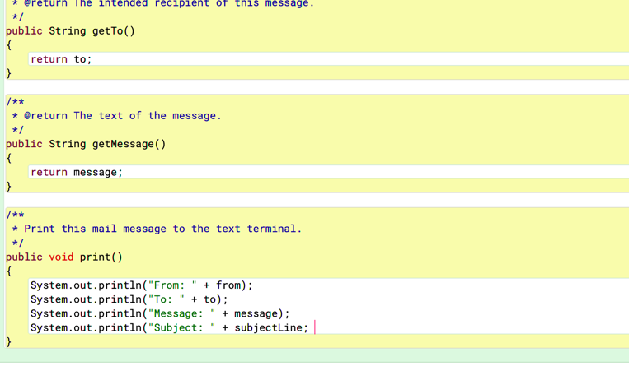
Bottom of MailClient code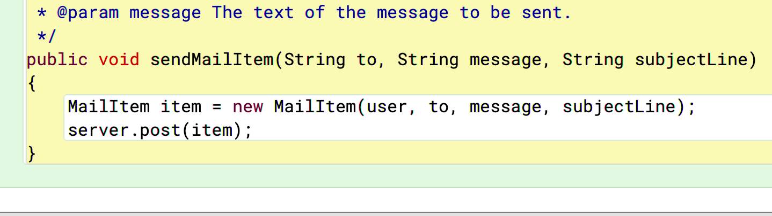

3.55:
Screen userScreen = new Screen();
If (numberOfPixels() > 200000) {
Screen = true;
}

3.56: There would need to be another field for seconds and it would have to be implemented everywhere such as the constructor and methods. updateDisplay() would also need a space to store seconds.

3.57:
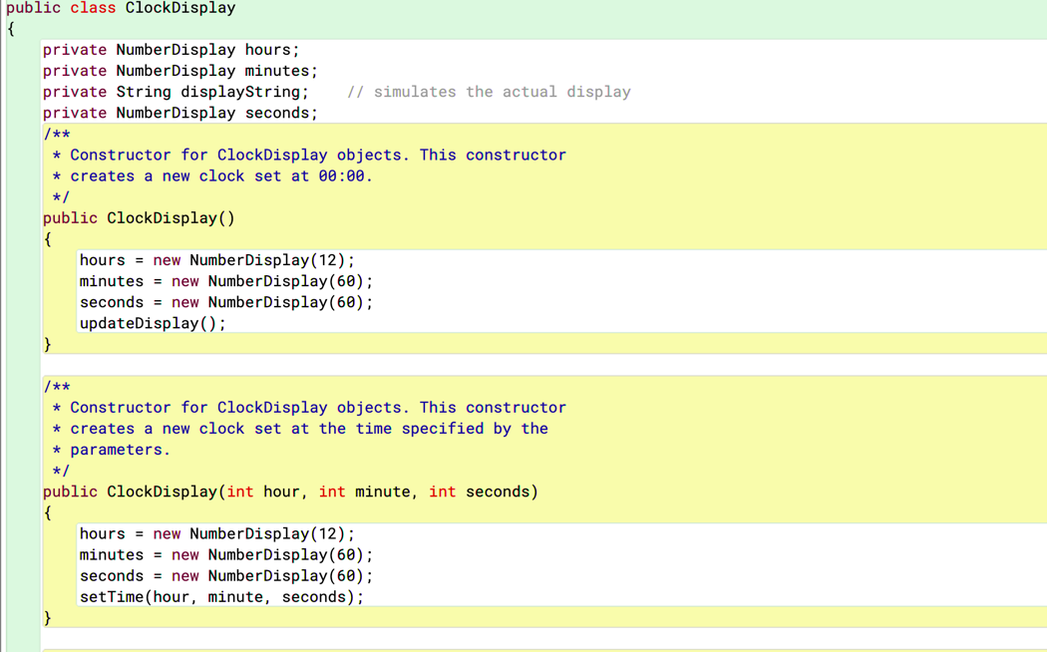

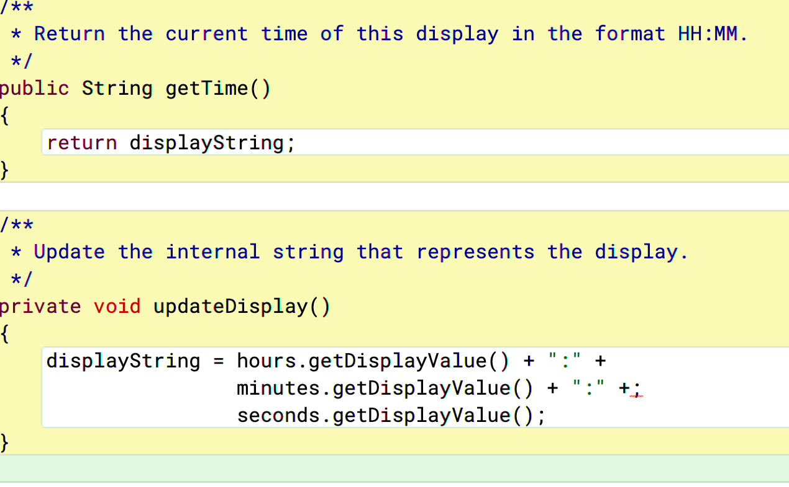

3.58: It could be done but would be complicated with a lot of nested if statements. It could be incremented on any value though.

3.59: It would be possible to have minutes tell hours etc and have them communicate I think. The way I would try to do it would involve Booleans and fields that equal true. Maybe I would then have the minutes or hours be set to false until a certain threshold and then switch to true which would indicate a rollover.

